FACULTY PROFILE FOR WEBSITE
Name | : | C.Sivapriya | 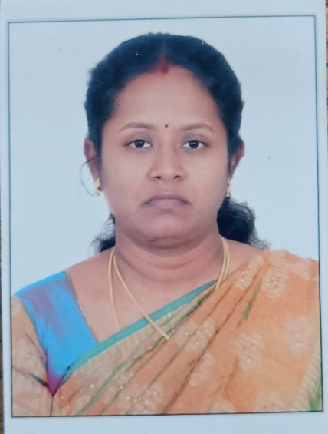
Designation |  | Asst. Prof.
Department |  | Architecture
Educational  Qualification |  | (Ph.D.) NIT Trichy  M.E.(Periyar Maniammai University) B.Arch (Bharathidasan University)
Subject of  Interest | : | Construction Management. Residential Energy consumption. Consumption behavior of residential occupants related to Energy.
Publications | : | International: 2
 |  | National: 3
Funded  Projects | : | Nil
Awards and  Achievements |  | Best Faculty Award 2016 (Periyar Maniammai University)
Others |  | 1. Working as Research Scholar in the project “Community Scale Energy Demand  Reduction in India (CEDRI)”.  Link of the Project Details: https://cedri.hw.ac.uk/  Link of the Project Team Details: https://cedri.hw.ac.uk/project-team/  2. Recently acquired GRIHA certified professional for V.2015 (GRIHA CP)
Contact  Address |  | C.Sivapriya  Asst. Prof.  Department of Architecture  Periyar Maniammai Institute of Science and Technology  Periyar Nagar, Vallam ,Thanjavur  Ph.no: +919994512343

